Data & AI Specialist
Practical Assessment
Overview
This practical gives you the chance to show how you work with data, from cleaning and preparation through to visualisation and AI incorporation. There are no trick questions and no single right answer. We want to see how you approach a problem, the decisions you make along the way, and how you communicate what you've done.
You have 7 days. If you don't finish everything, submit what you have. Thoughtful partial work tells us more than a rushed complete submission.
The dataset provided (Excel: TechSolve – Ticket Data) is entirely synthetic - no real customer or business data is included. You're welcome to share your completed work on a personal GitHub or portfolio as a demonstration of your skills, both for this role and beyond.

The Scenario
TechSolve IT is a fictional managed service provider. Their operations manager has asked for better visibility into customer support performance. They want to understand what types of issues are being raised, how they're being handled, and where there's room to improve.
You've been given an export of their ticket data to work with.
Part 1: Source, Combine & Prepare
Using the provided dataset, combine it with at least one external data source (for example, NZ public holidays, NZ weather data, or another source you think adds value). Transform and clean the data following best practices. This includes streamlining support ticket issues into a consistent set of categories and sub-categories suitable for reporting.
Part 2: Visualise
Create a Power BI dashboard (or equivalent) that presents support ticket data from 2024-2025. Include reporting on ticket issues, status and time to resolution. Incorporate visuals that combine the ticket data with your external data source. Beyond the essentials, include anything you think would be valuable for an operations manager.
Part 3: AI Agent
Build an AI agent that can inspect your dataset and respond to natural language questions about the data. The agent should be able to answer operational questions and provide useful feedback. For example, a manager might ask about ticket trends, team performance, or problem areas.

Review (required)
Along with your practical work, please include a written response covering the following:
- Where did your datasets come from, and why did you choose them?
A1. I got NZ public holiday dates from the Employment New Zealand website because it provides official and trusted dates. The reason why I picked this is to analyse whether public holidays are a major reason for delays in resolution time.
https://www.employment.govt.nz/leave-and-holidays/public-holidays/previous-years-public-holidays-and-anniversary-dates

- Describe your process for working through this scenario.
A2. Please refer to the separate sections below.

- What tools and programs did you use, and why those over alternatives?
A3. Data Cleaning: Python. Visualization: Power BI. AI Agent: LM Studio. Debugging: ChatGPT.
In general, I picked low-cost and stable programs for use in a Windows environment. For the rest of the reasons, please refer to the sections below.

- What would you do differently? What did you find most challenging?
A4. If I did this again, I would use the GPT API to connect the AI agent to a cloud server. More advanced models can provide faster and more accurate responses. However, the cost could be much higher cost.
I found that finding a trustworthy and free AI agent was challenging, as I needed to check its version history and security background to make sure it was safe to use.
Normally, actual Bronze raw data would be much messier than the current dataset. Therefore, the data cleaning process would take longer than the current one in this example (Current one is almost Silver Level dataset).

- Roughly how long did you spend on each phase?
A5. Each section lists the time I spent.

- Did you use AI tools during this practical? If so, how?
A6. Yes, I used AI for brainstorming the steps and setting up the file structure, doing a quick Python clean-up (as I did not install the relevant Azure Data Factory tools for cleaning, it was quicker to use Python for the cleaning process). Lastly, doing searching for a free AI agent.

Submission
Submit your work by the date noted in your email. Include your dataset, dashboard, AI agent access or recording, and your written review. Partial submissions are welcome, but please include the Review section.
Part 1: Source, Combine & Prepare (Half-Day)
1.1 Brainstorming: Firstly, I decided to use geographic data from NZ_TLA to identify where the customers come from, as shown in the graph below. However, the raw data only provides broad regional information, which makes it difficult to determine the actual latitude/longitude.

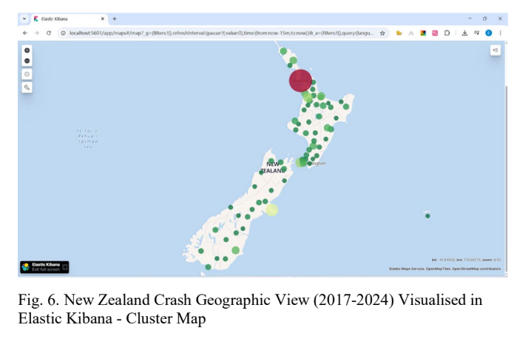
1.1 Holiday Date Excel

1.2 Data Cleaning
Below sections have been uploaded into Github:

1.2.1 Clean the data with duplicate: If the customer_name or customer_email similar AND ticket_id same, Drop roles.
Clean NULL values: If customer_name or customer_email or customer_id is Null, Drop roles

1.2.2 Select up the relevant columns according to client’s request:
Key info: As below screenshorts.
what types of issues are being raised: issue_description
how they're being handled: resolution_notes
where there's room to improve: ticket_created_date ticket_resolved_date first_response_time_hours resolution_time_hours csat_score issue_complexity_score

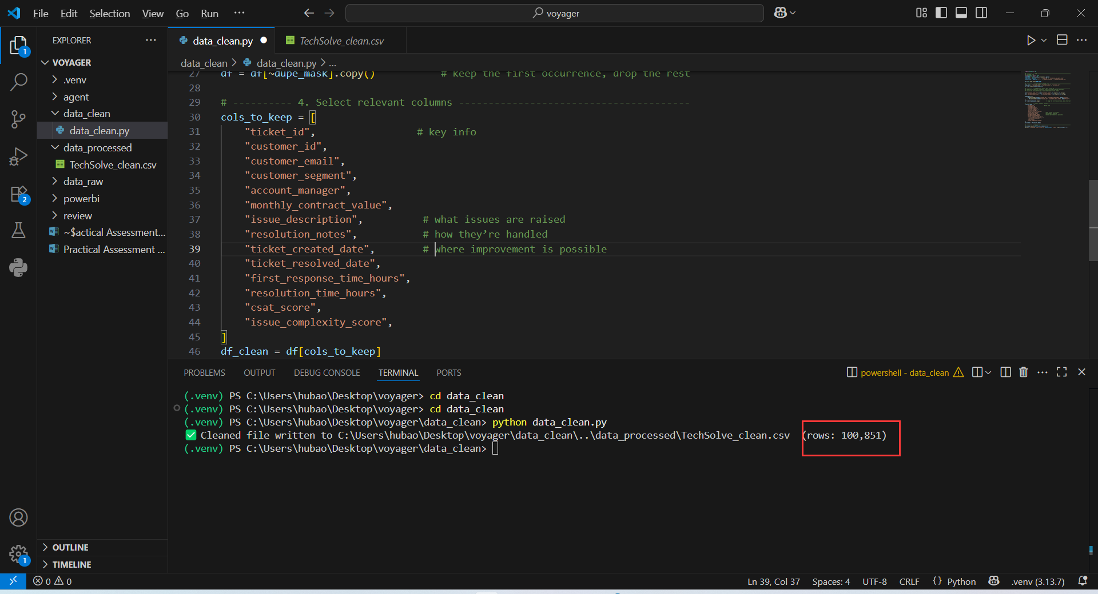

  - Questions can be present in Part 2

1.How many customers are still waiting for the account manager to solve problem (account_manager=Null, monthly_contract_value > 0, Priority level High to Low)

2. Customer satisfaction connections is directly connected with solution time? (resolution_time_hours csat_score issue_complexity_score)

3.Is the customer’s priority level is purely based on the monthly_contract_value and subscription_type?

Part 2: Visualise (1 Day)
  - Uploading and connection
I uploaded the two cleaned tables into Power BI, as shown in the two graphs below. In Power Query, I simply copied the ticket_created_date column into a new column called WorkDate. I then added a new column called isHoliday, which compares the holiday date with WorkDate. If the dates do not match, the value is filled with NULL.
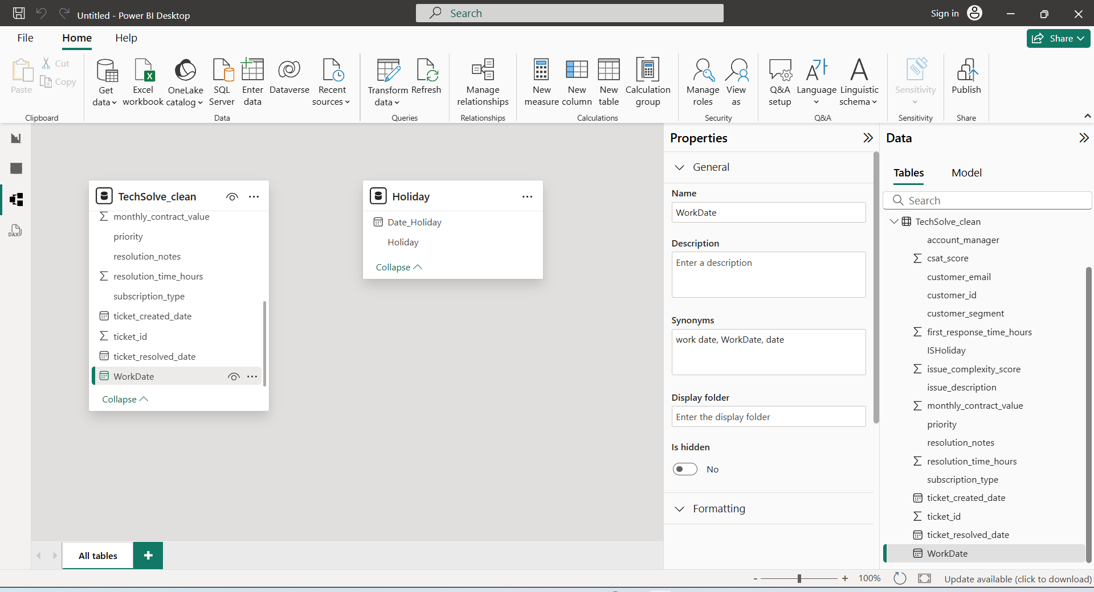
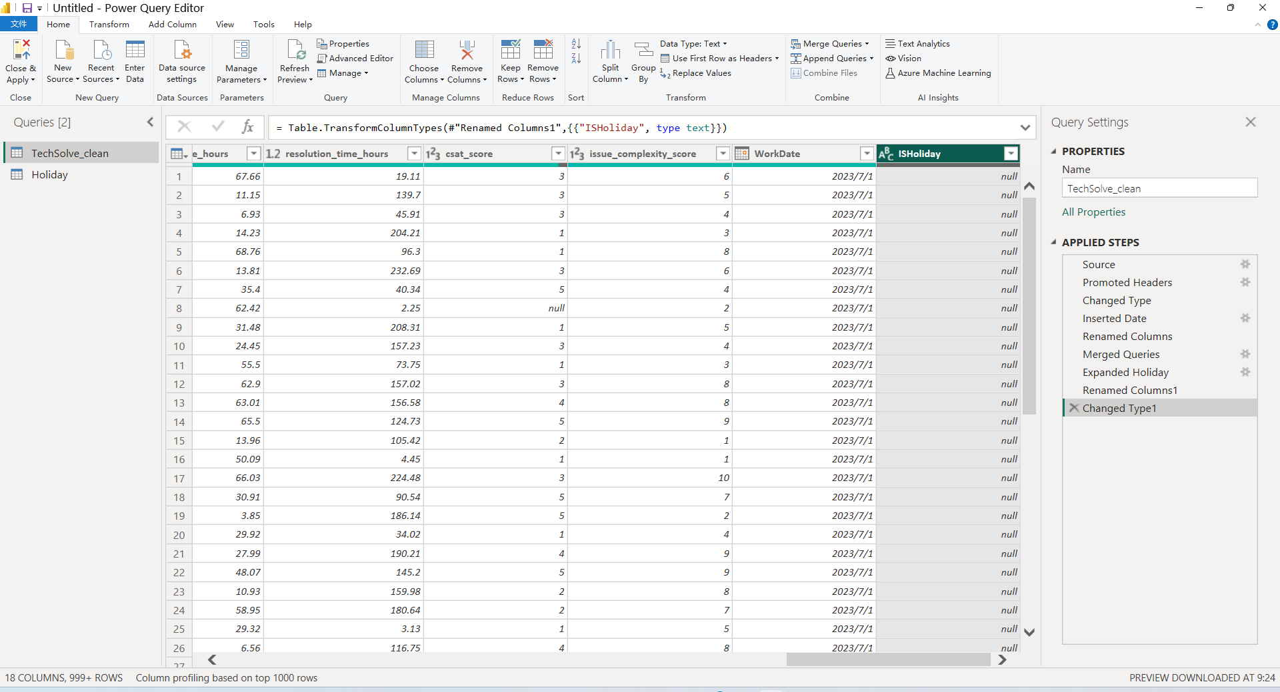

2.2 Holiday day affect efficiency?
As shown in the two graphs below, the average resolution time is 121 hours. We can clearly see that the main holiday period occurs in late December and early January. During this period, there are some delays in resolution time; however, the overall impact is not significant compared with the average resolution time.
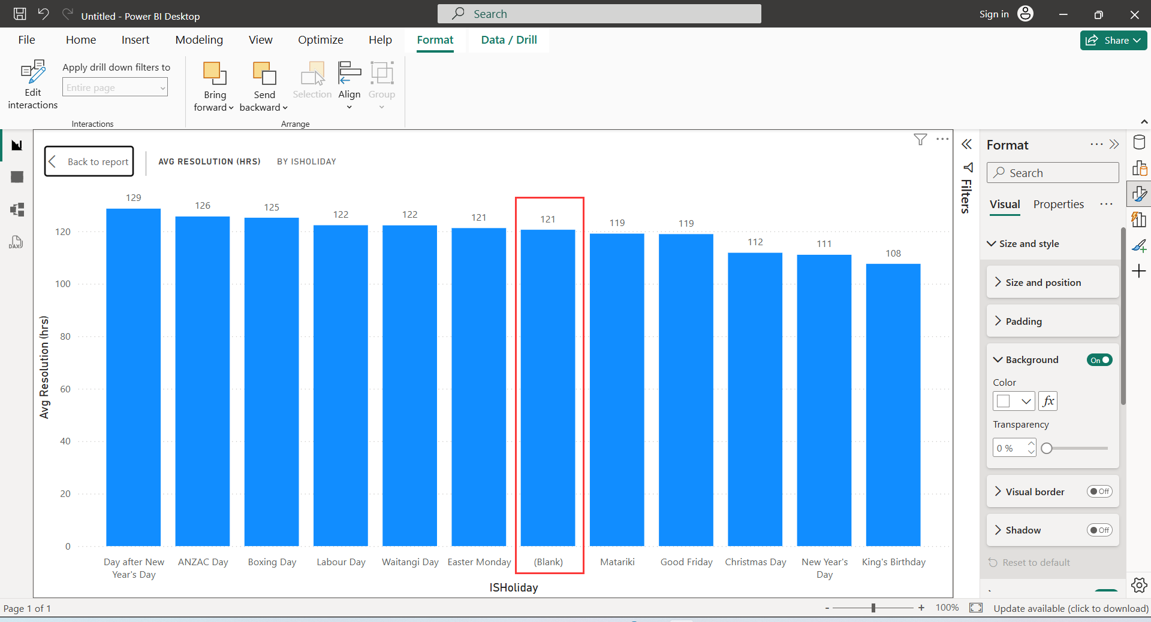
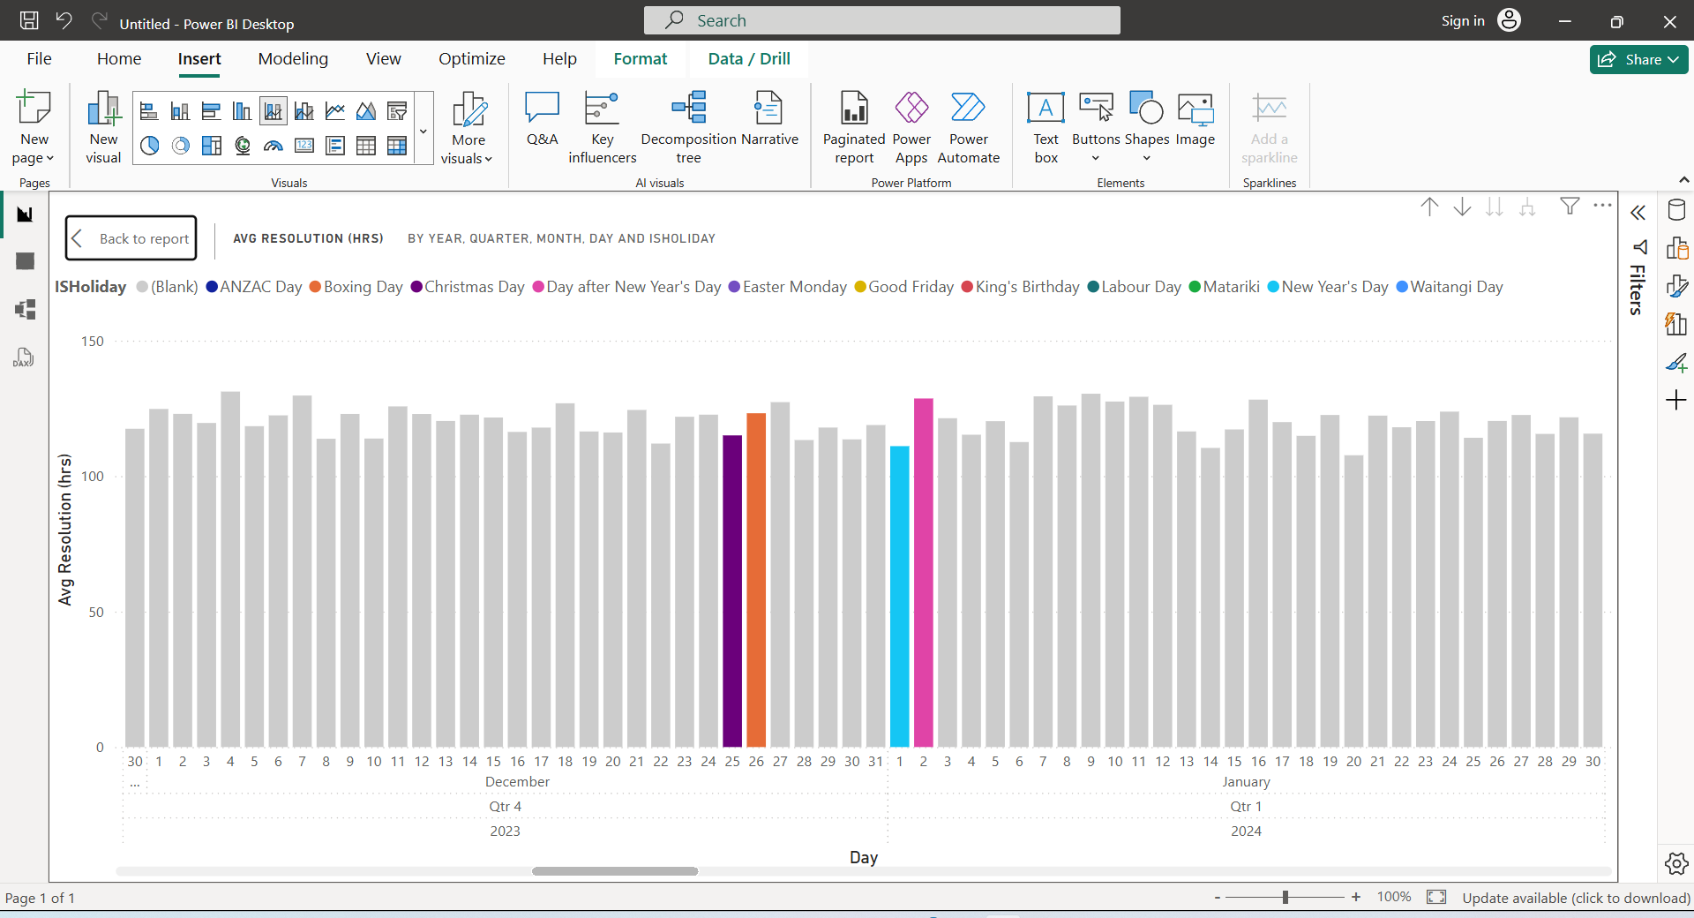

2.3 Dashboard Overview
The overview dashboard for 2024 is shown in the graph below. Firstly, the 10 different issue types are divided equally. The total number of tickets raised each month remains steady level, with an average of roughly 5.5K tickets.
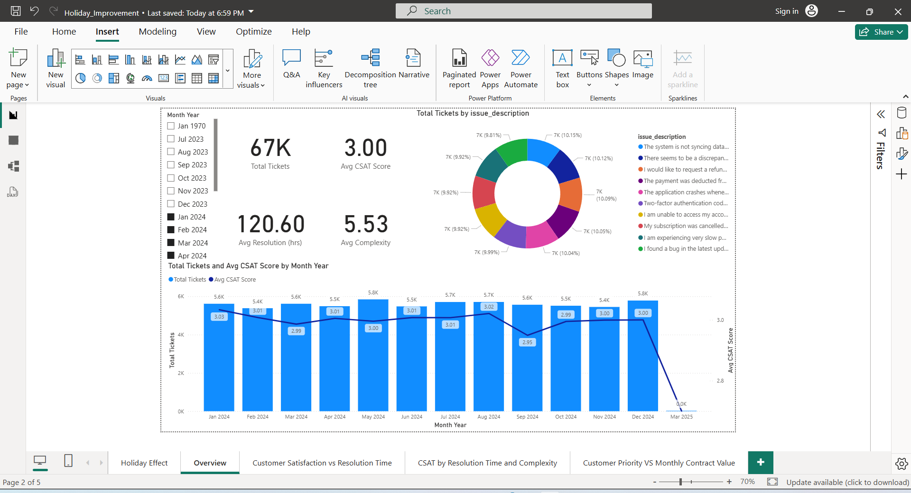

However, the lowest customer satisfaction score occurred in September 2024, with an average score of 2.95. We can further investigate this month to identify the main issue contributing to the low score. The analysis shows that the key issue was: “There seems to be a discrepancy in my billing statement for this month.”

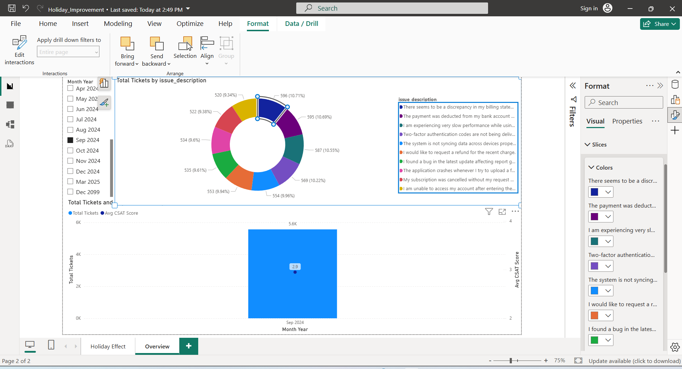

2.4 Customer satisfaction VS Resolution dashboard
To identify the relationship in the title, I used Scatter Plot to demonstrate the connection. Due to there are lots of bubbles sit averagely between score 1 to 5. Thus, there is no significant relationship.

Next graphs explain the question of “Does complexity explain or change that relationship?” The answer is there is tiny relationship when comparing with average scores.
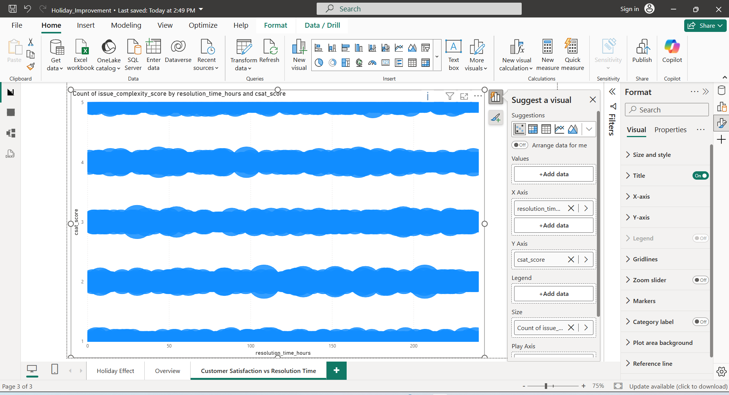

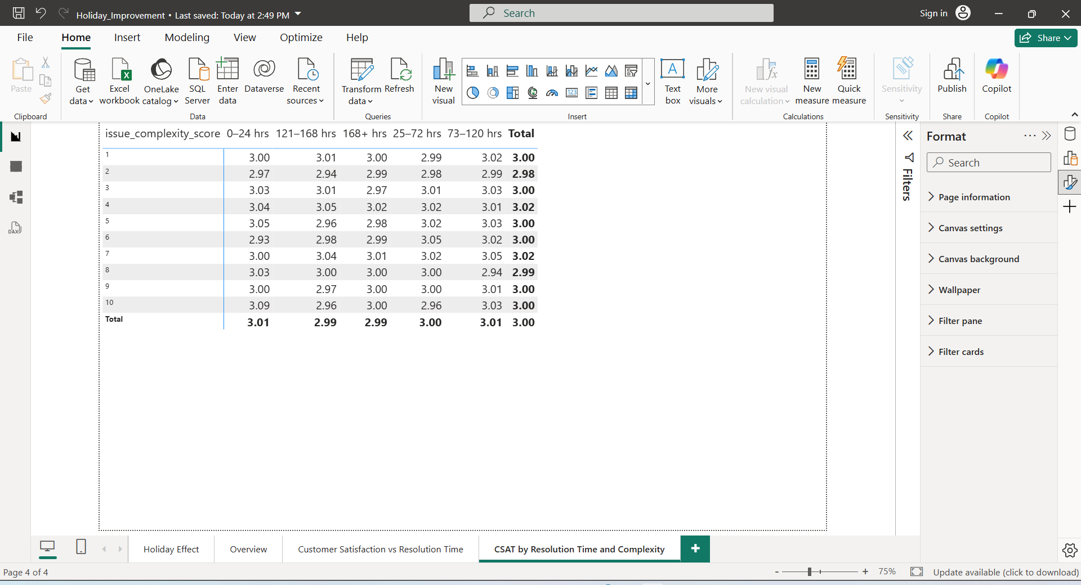

2.5 Subscription type VS Average Contract Value
The two graphs below explain whether subscription type or average contract value has an impact on ticket priority. It can easily tell the level is all the same, so it does not appear to be a significant relationship between these factors and ticket priority.
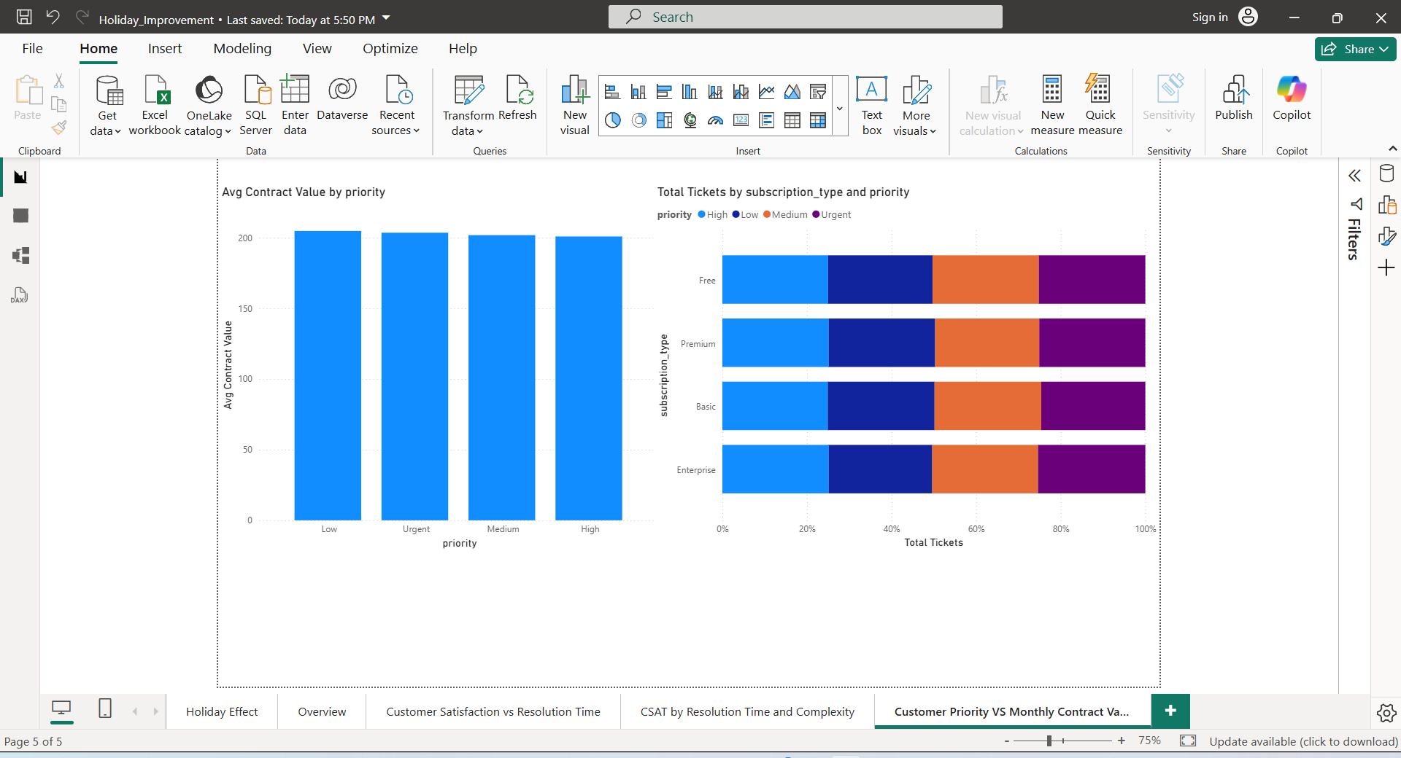
Part 3: AI Agent (Half-Day)
Only Video is included: https://youtu.be/s2dCczzrkVE
In this part I am using GPT to give me suggestion of a free local AI agent option.
Firstly, I tried to research Ollama. however, when I check the updated version, there are some security issues in the cloud server.
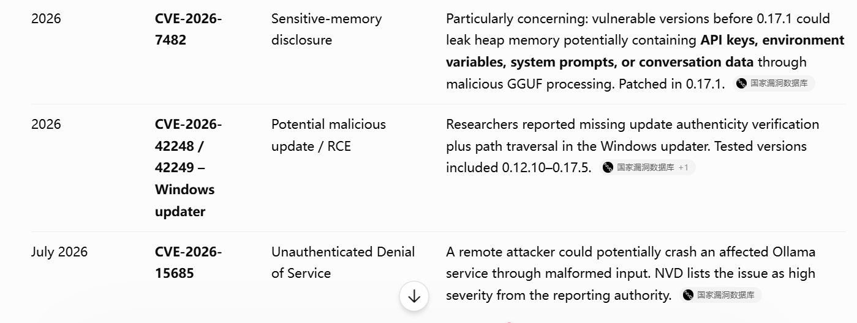
Then I pick LM studio and download a small opensource model to run locally.
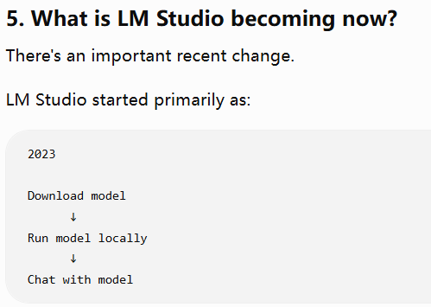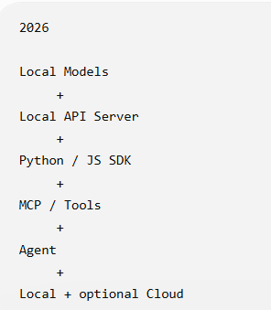
The whole process is listed as below: Local AI agent: LM Studio, Models: Qwen3 4B 2507 (Open sourced, small size 2.5GB, latest version 303days ago), UI: Streamlit
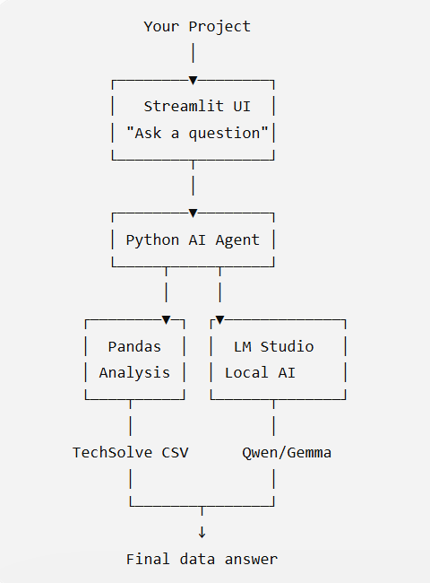
RUN: python -m streamlit run app.py
Test Questions
- Give me a data type and shape overview
- Which months have the highest total tickets
- What is the average score of csat_score
